1.

2.

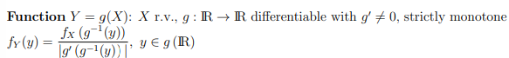

3.





